MONITORING TASK

1)ENABLE CLOUDTRAIL MONITORING AND STORE THE EVENTS IN S3 AND CLOUDWATCH LOG EVENTS.
- Go to cloud trail – create trail
- Create trail work flow

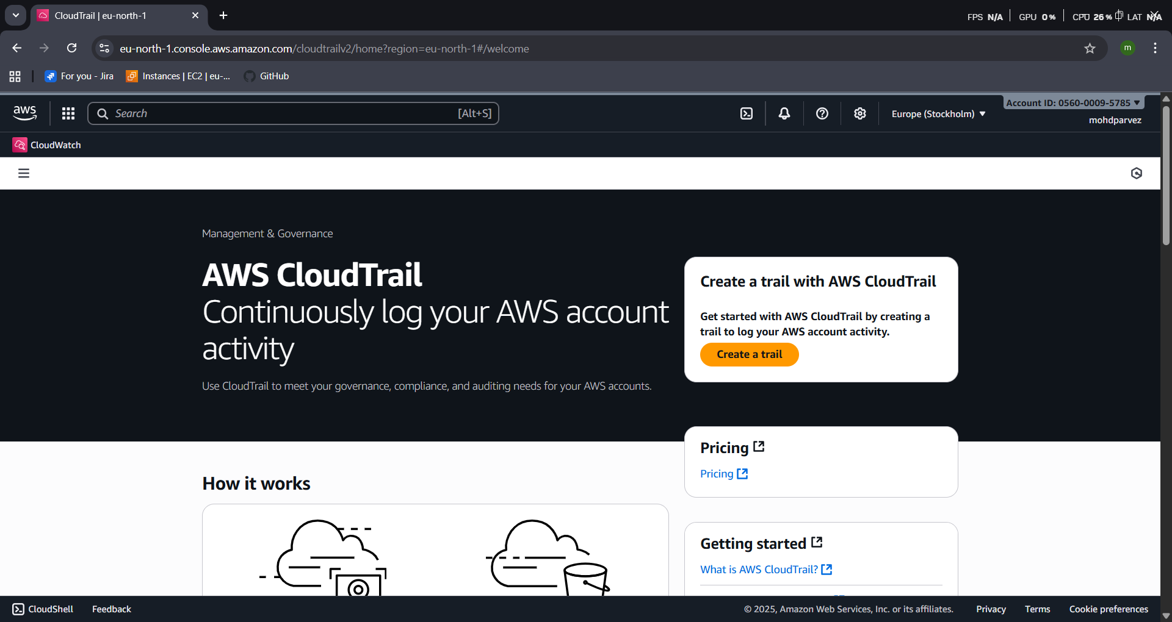
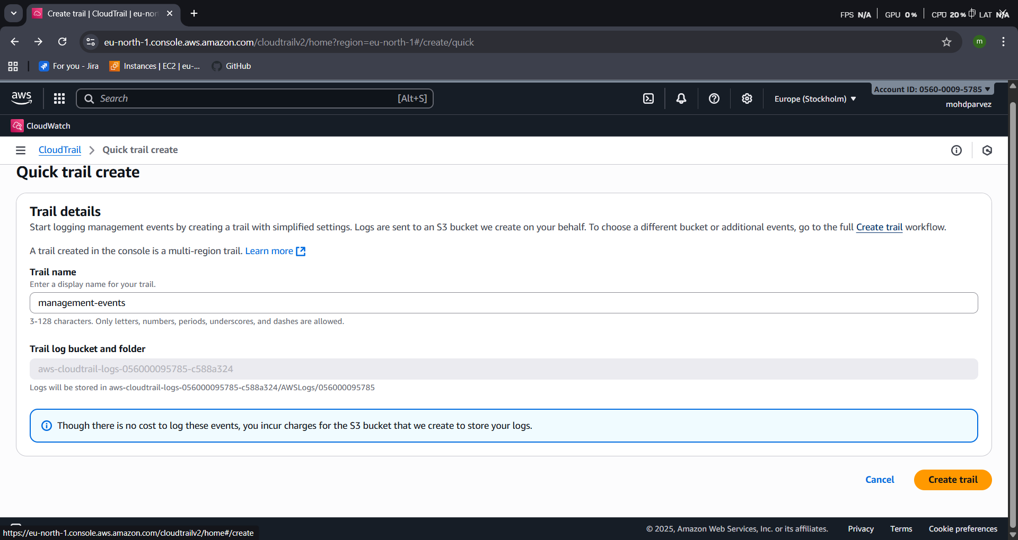
- Give the Name to the trail
- Enable logs and enable
- Create ne role for sns alert and then create trail logs
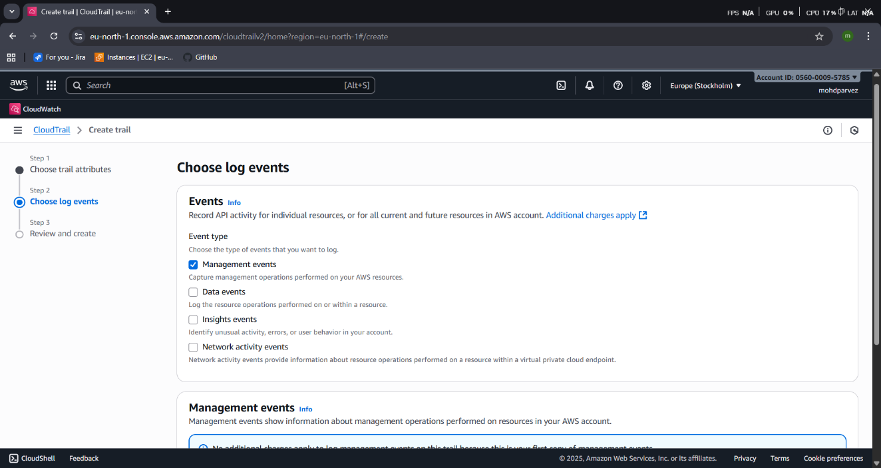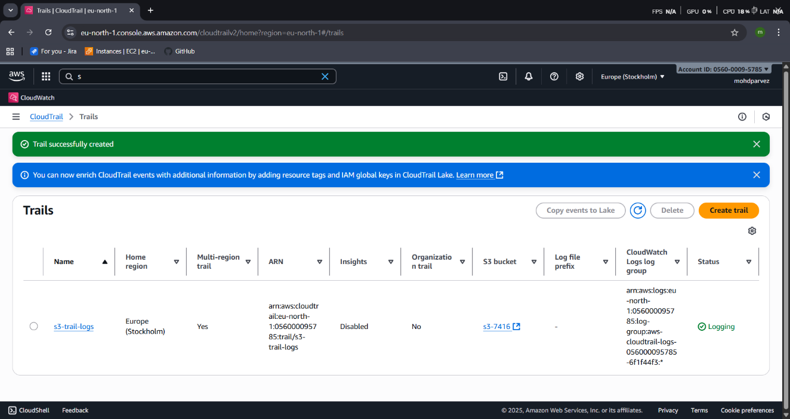
- Now go to cloud watch log groupsyou find the log created log streams check the logs.
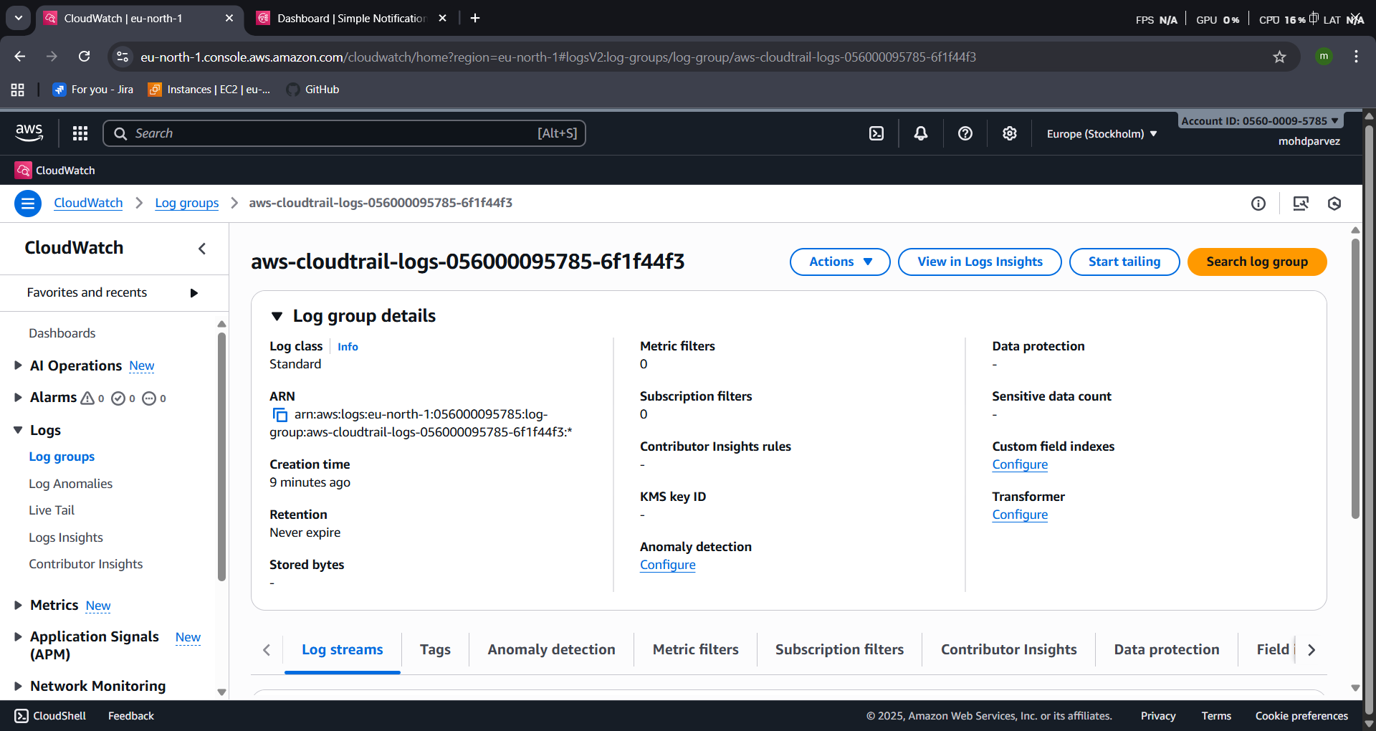

2) Enable SNS for cloudtrial to send alert on email.
- Configure the sns for the cloud trail to send the alert to your phone or email
- Got to sns (simple notification service)
- Create subscriptiontopic nameprovide your email address and create the topic
- Confirm the the subscription fro your email then the sns is created successfully
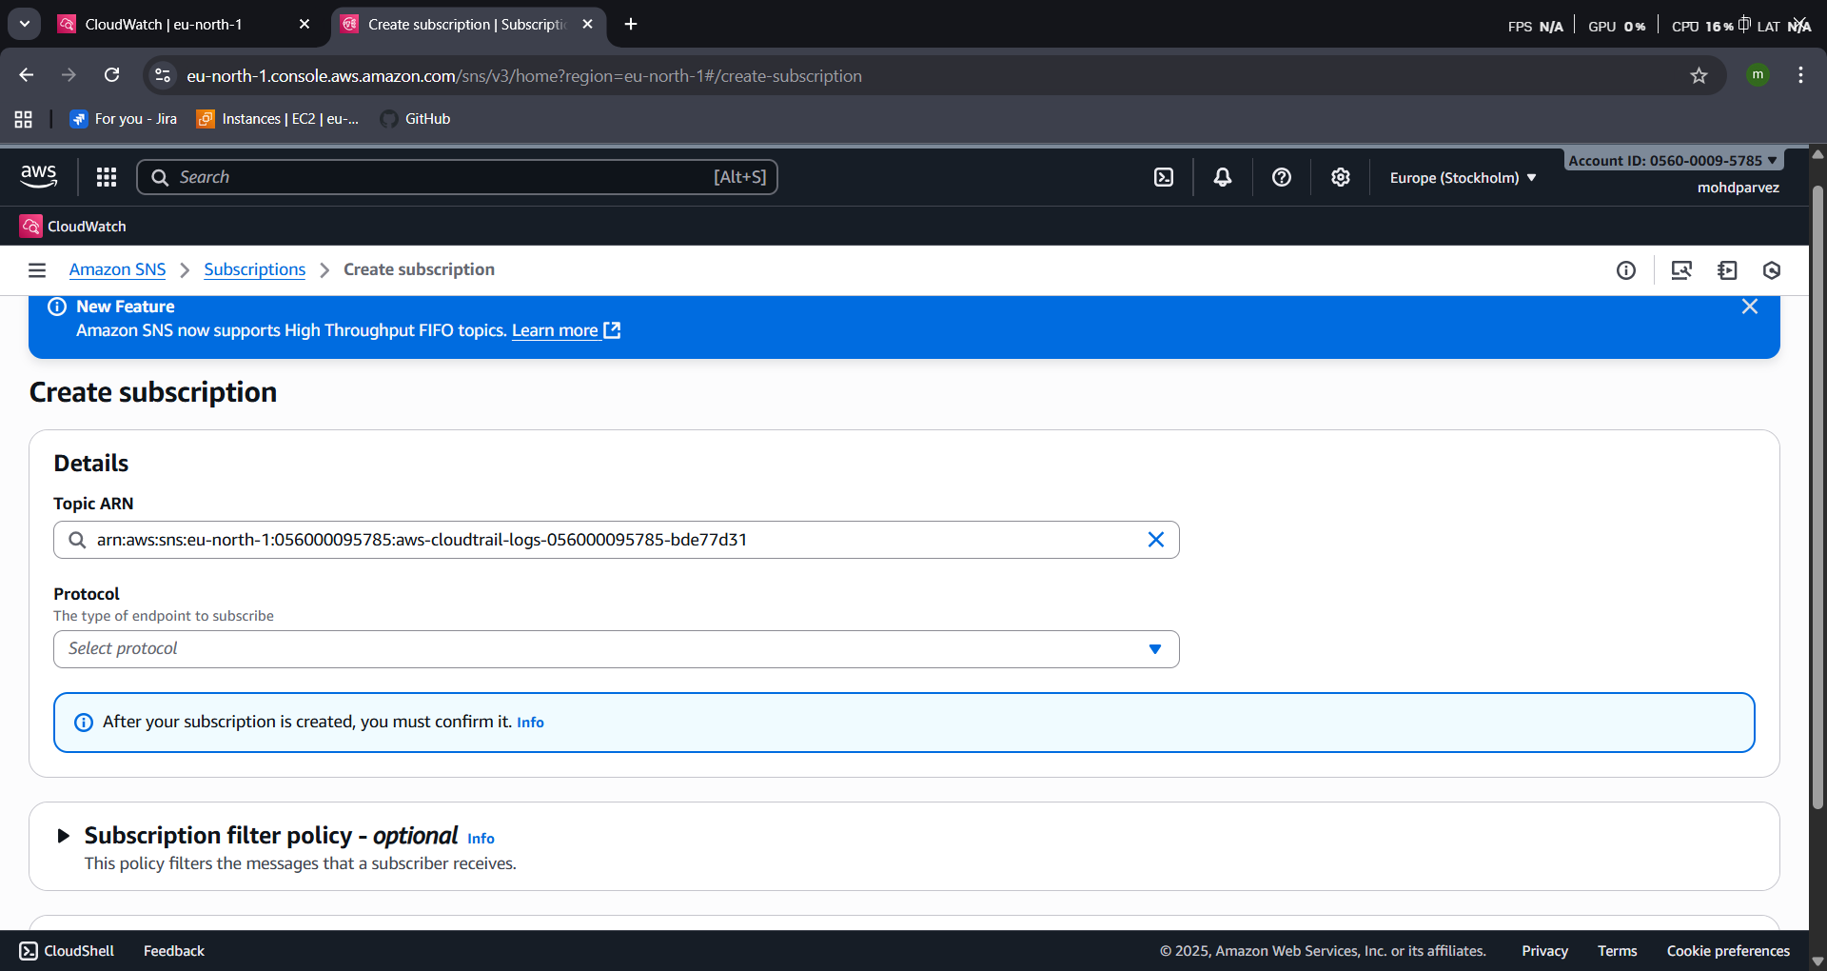
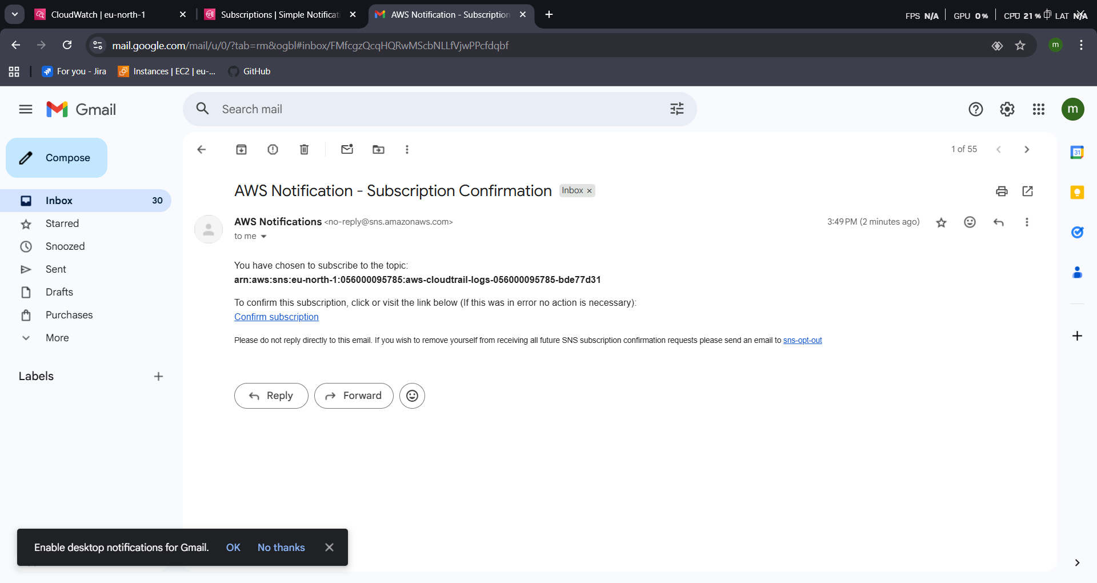
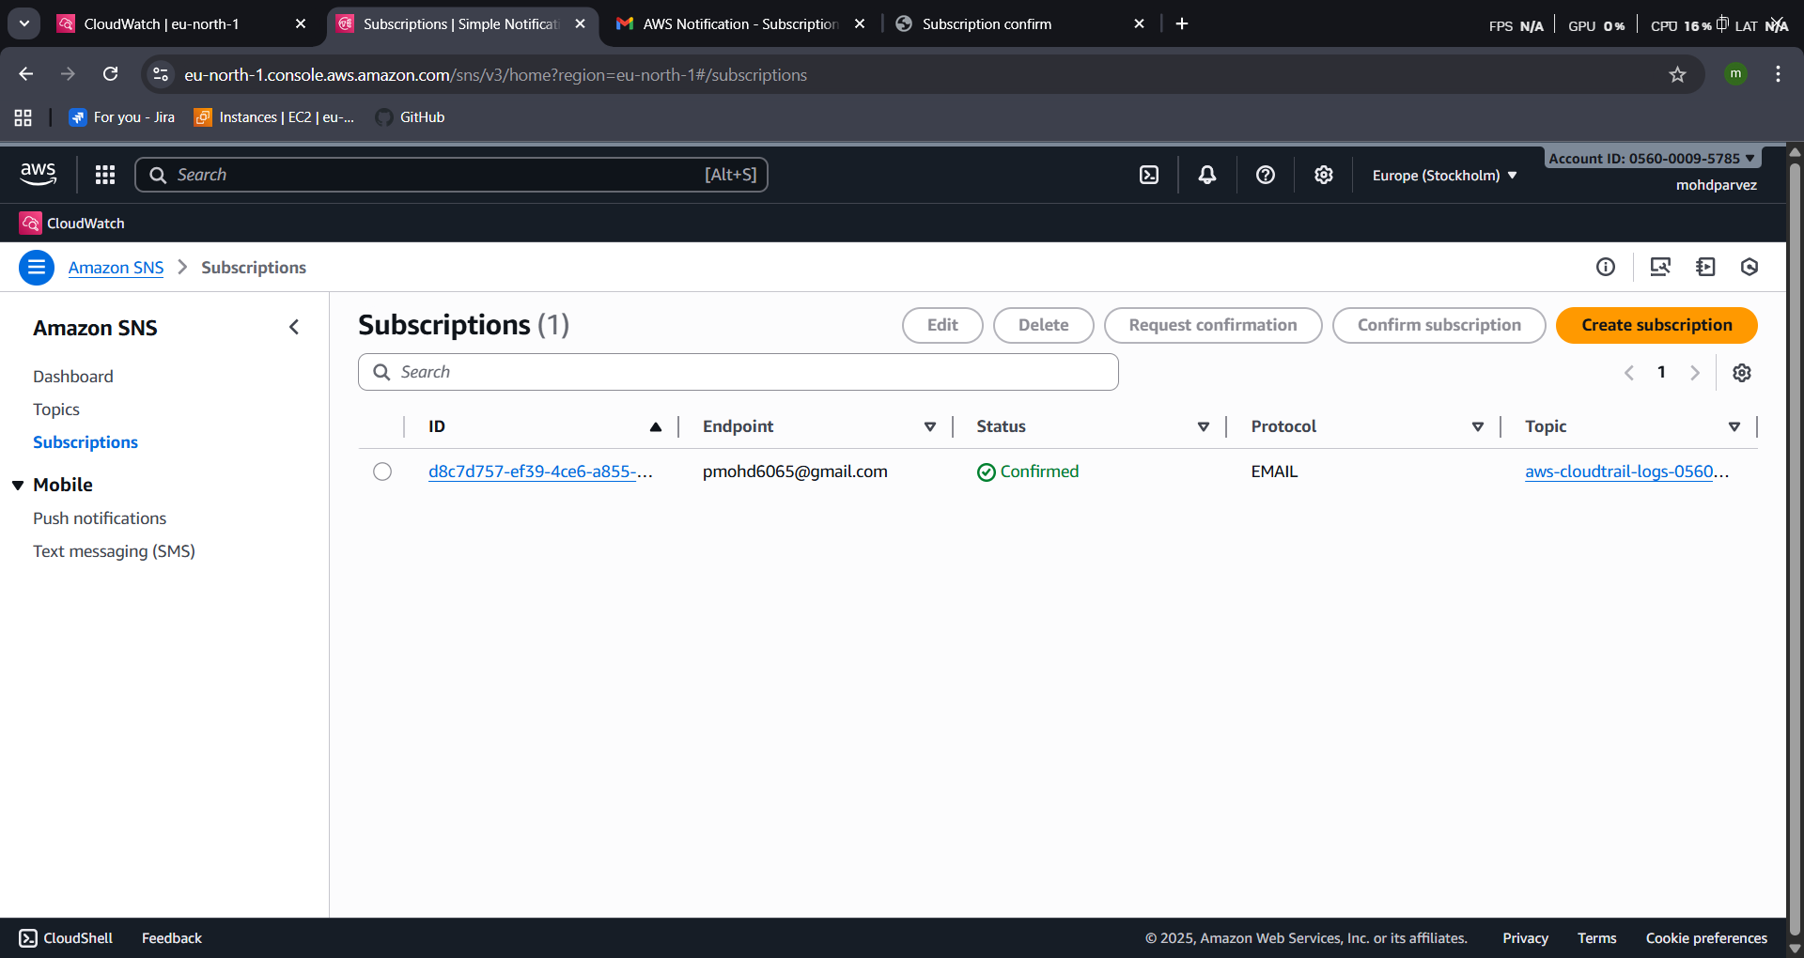
3) Configure cloud watch monitoring and record the cpu utilization and other metrics of ec2.
- Launch one ec2 instance
- Go to cloud watchdashboardcreate daash board
- Go to the dash board created add metric graphs select ec2select the graph you want to monitor create widget type graph sleect and create the widget you can monitor cpu utiliation
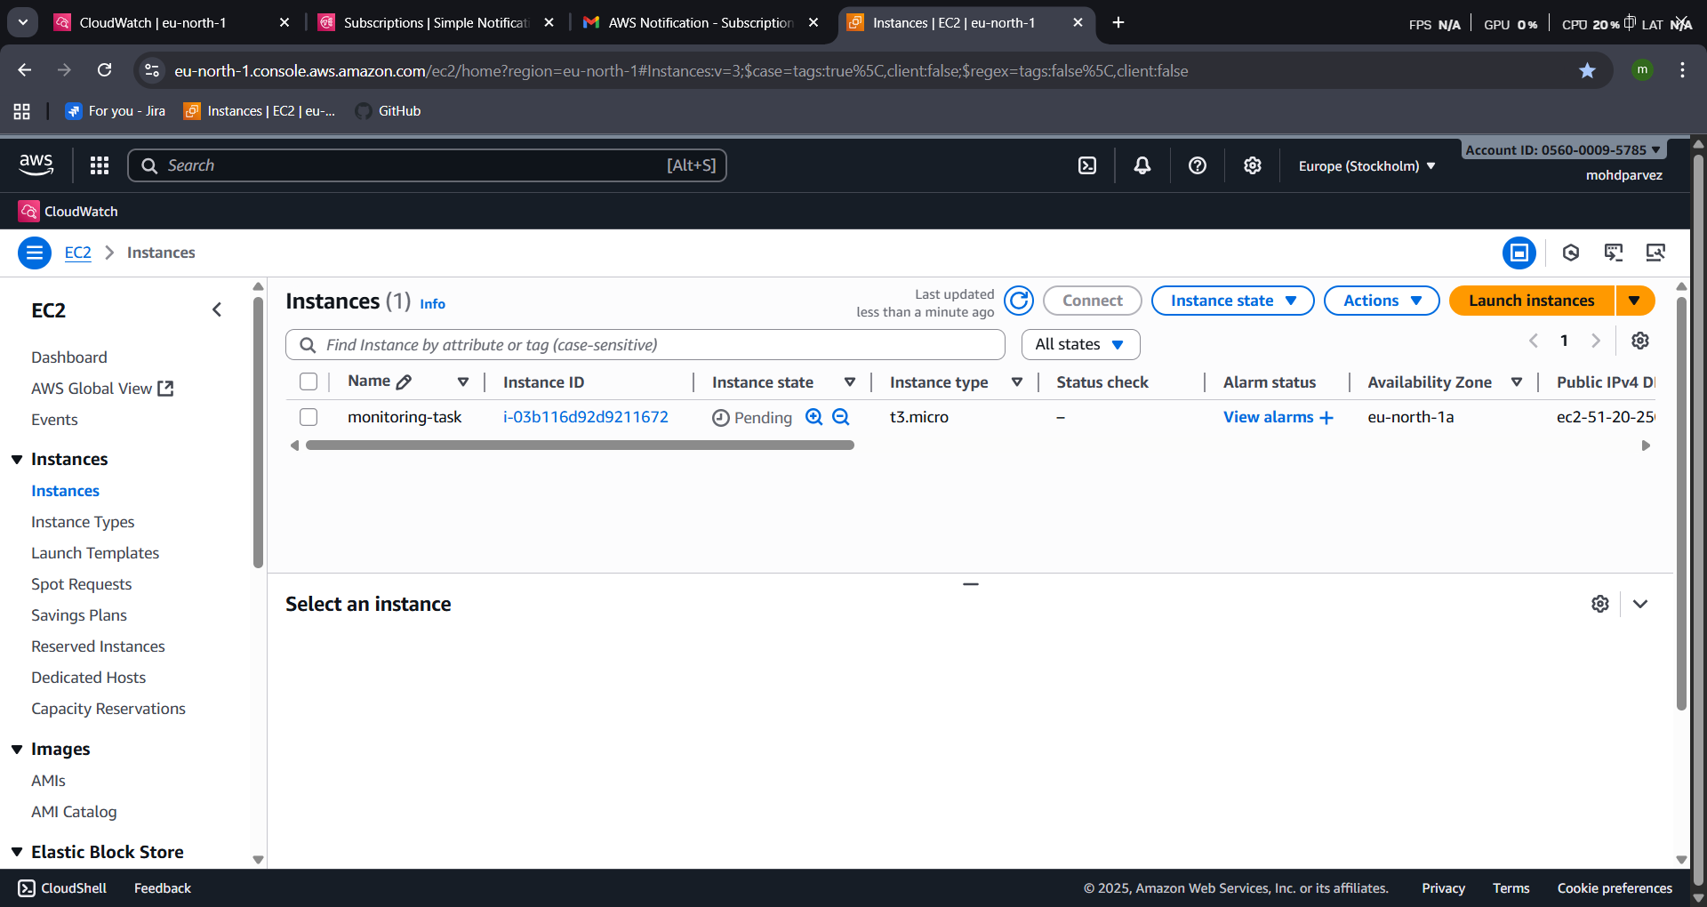
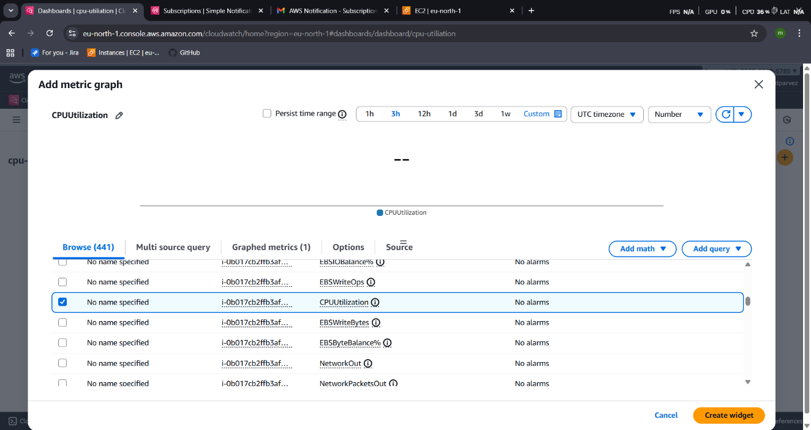
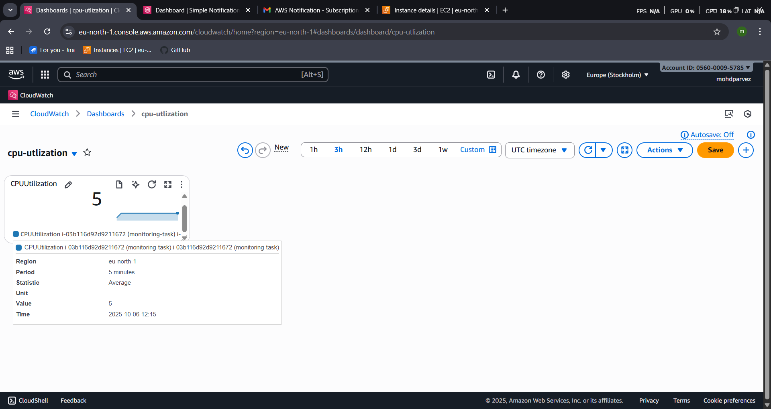
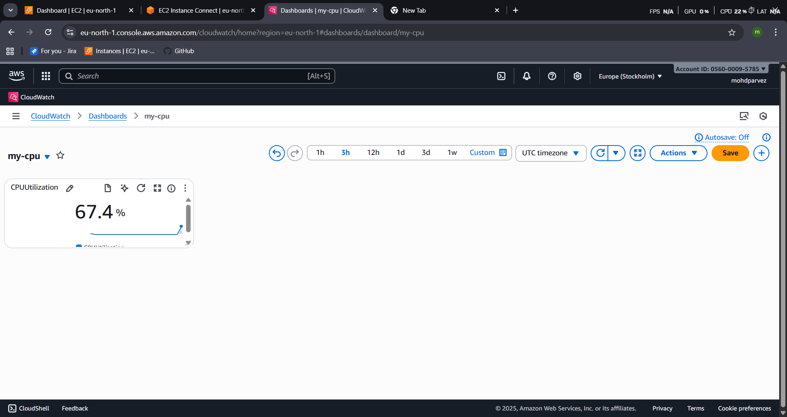

4) Create one alarm to send alert to email if the cpu utilization is more than 70 percent.
- Go to cloud watch create alarm
- Select the metricor search with instance idselect spu utilizationgive the parameter greater than 70 select the sns create alarm
- Now check the alarm and email will be sent to your mail id for the usage is more than the 70%
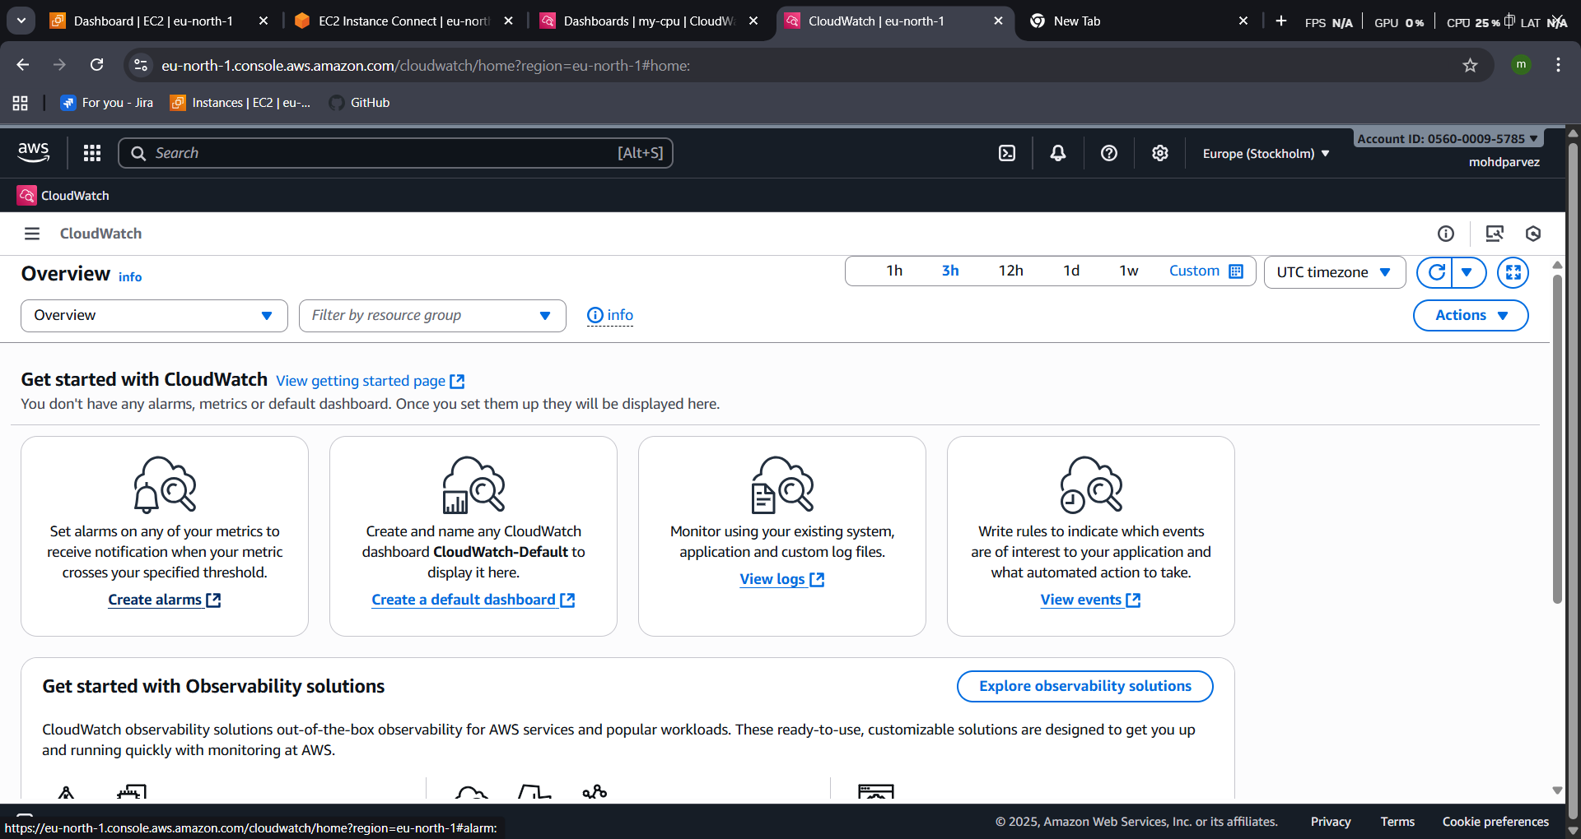
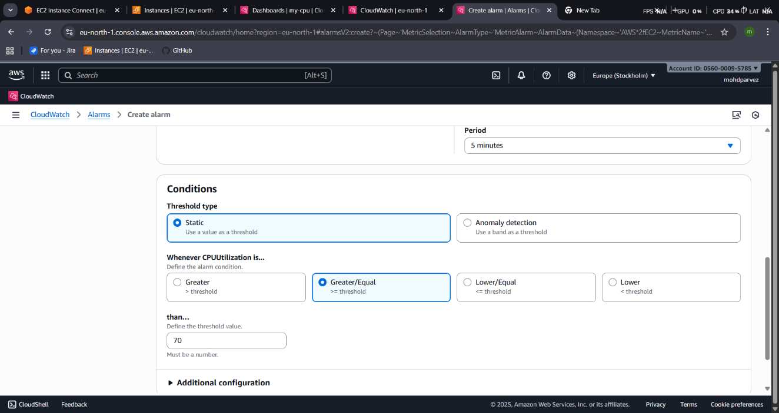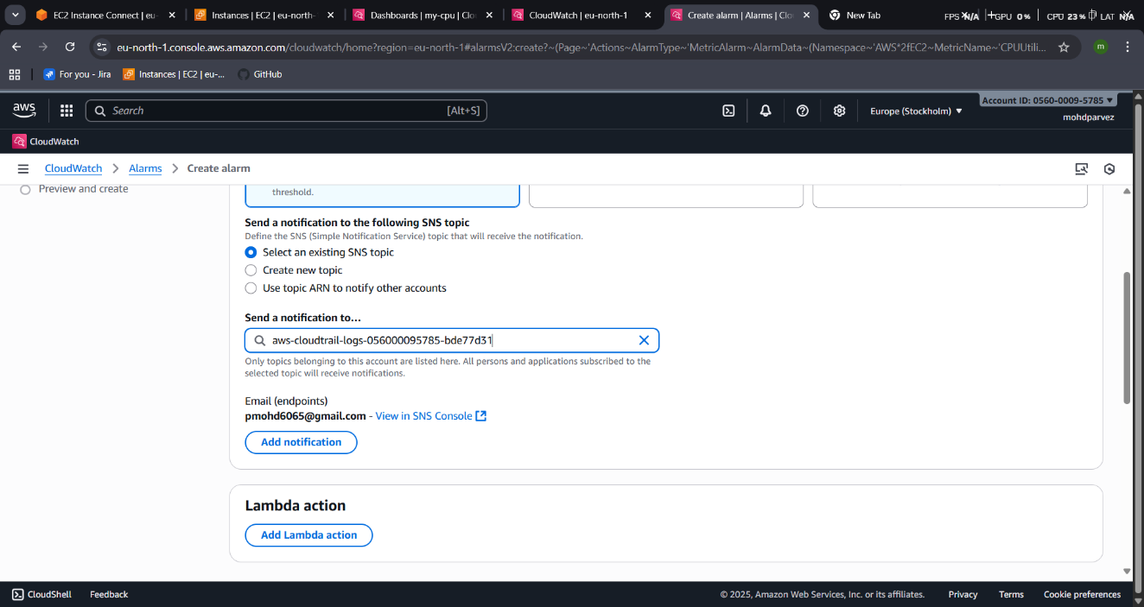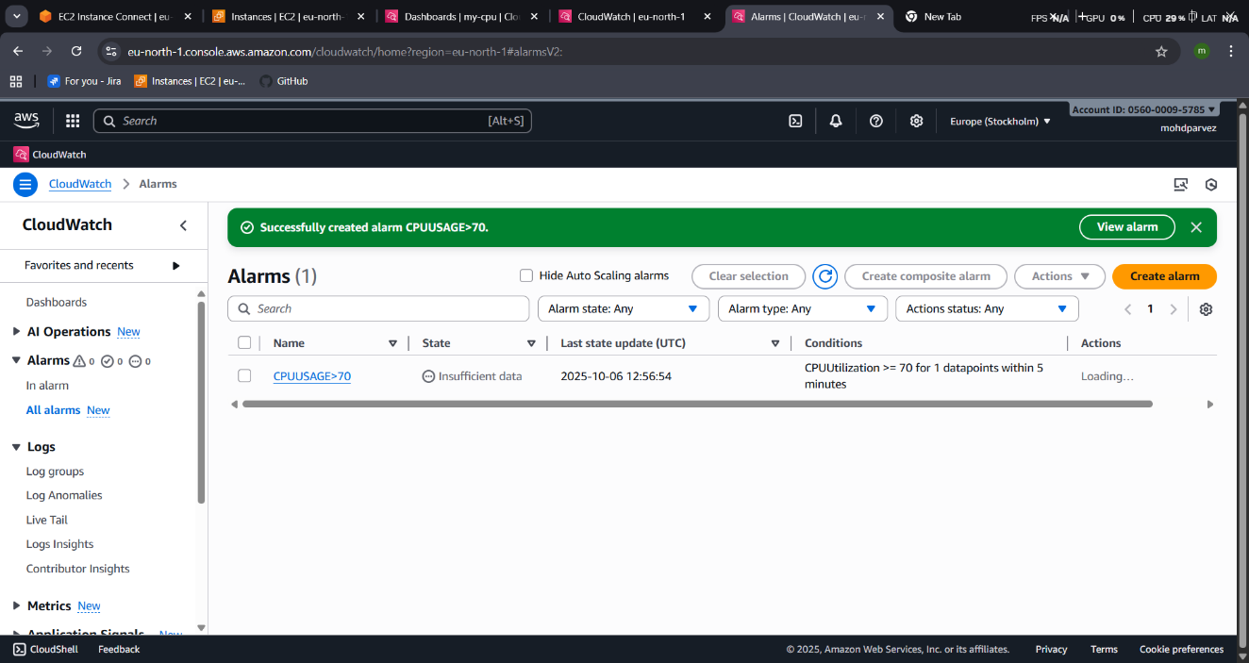
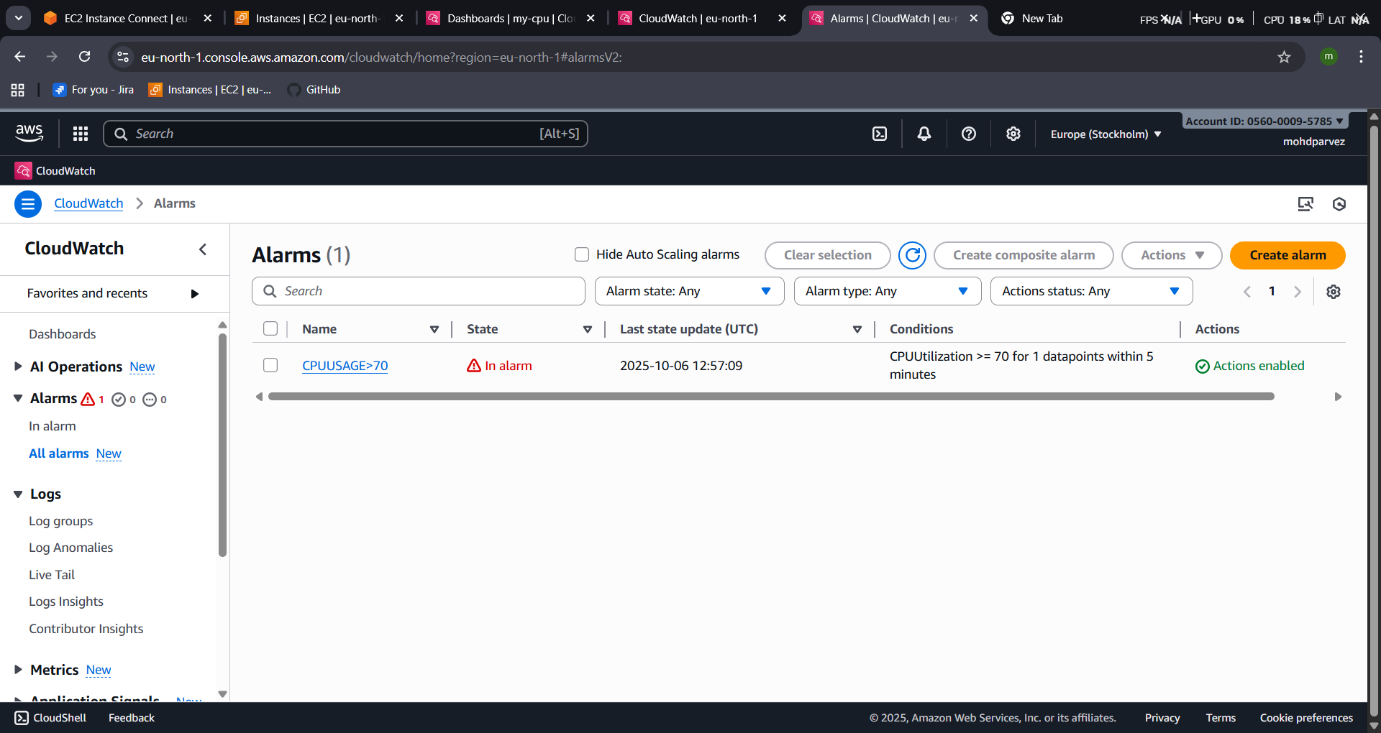
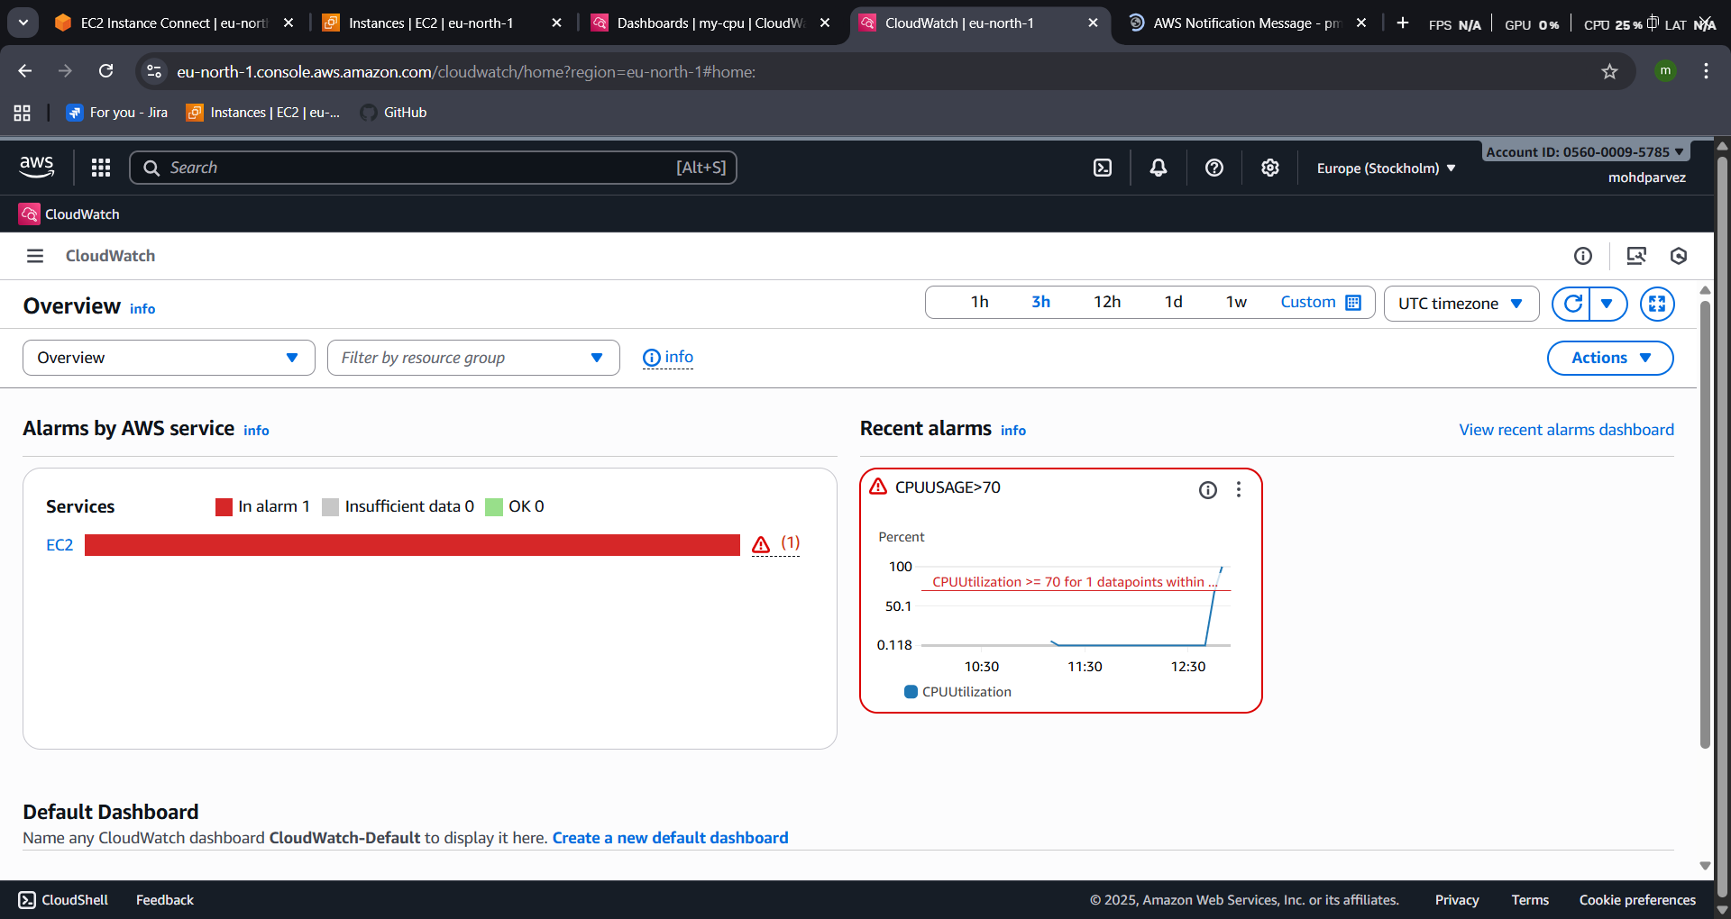
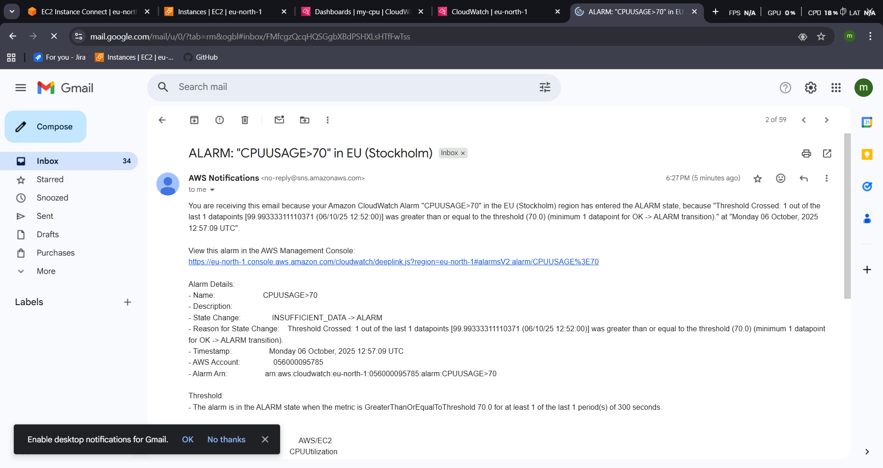
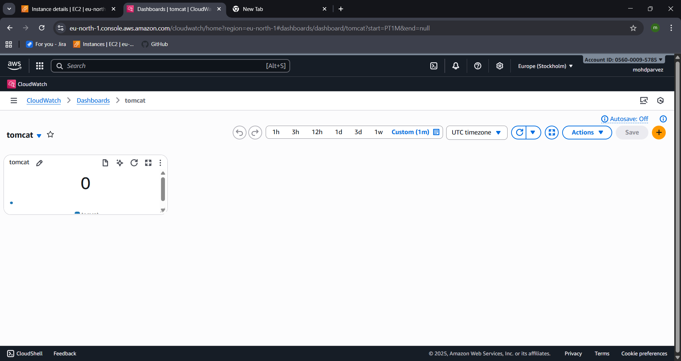
- Tomcat has been monitored using dash board

5) Create Dashboard and monitor tomcat service wether it is running or not and send the alert
- Go to colod watch create dash board create dash boardnameselect metrix tomcatthen create widget
- Create alarm create alarm select the metric select the valuein alarmtomcat is stoped or running
- “ 0” is stopped & “ 1” IS RUNNING


6) Create Dashboard and monitor nginx service to send the alert if nginx is not running.
- Install nginx and start the nginx
- Write a script to check and monitor the nginx service and push metrics to the cloud watch
- create dash board find nginx select you can see the nginx is being monitored
- create cronjob for the script
- script
#!/bin/bash

#set -x

# Get the instance ID
INSTANCE_ID=$(aws ec2 describe-instances --query "Reservations[].Instances[].InstanceId" --output text)

# Function to check NGINX status
checkNginxStatus(){
if systemctl is-active --quiet nginx; then
echo 1
else
echo 0
fi
}

# Get NGINX status
STATUS=$(checkNginxStatus)

# Push metric to CloudWatch
aws --region ap-south-1 cloudwatch put-metric-data \
--metric-name nginx \
--value "$STATUS" \
--namespace nginx \
--dimensions InstanceId=$INSTANCE_ID

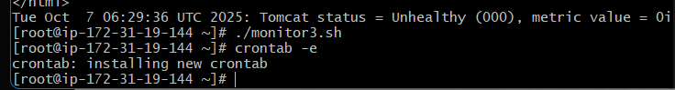
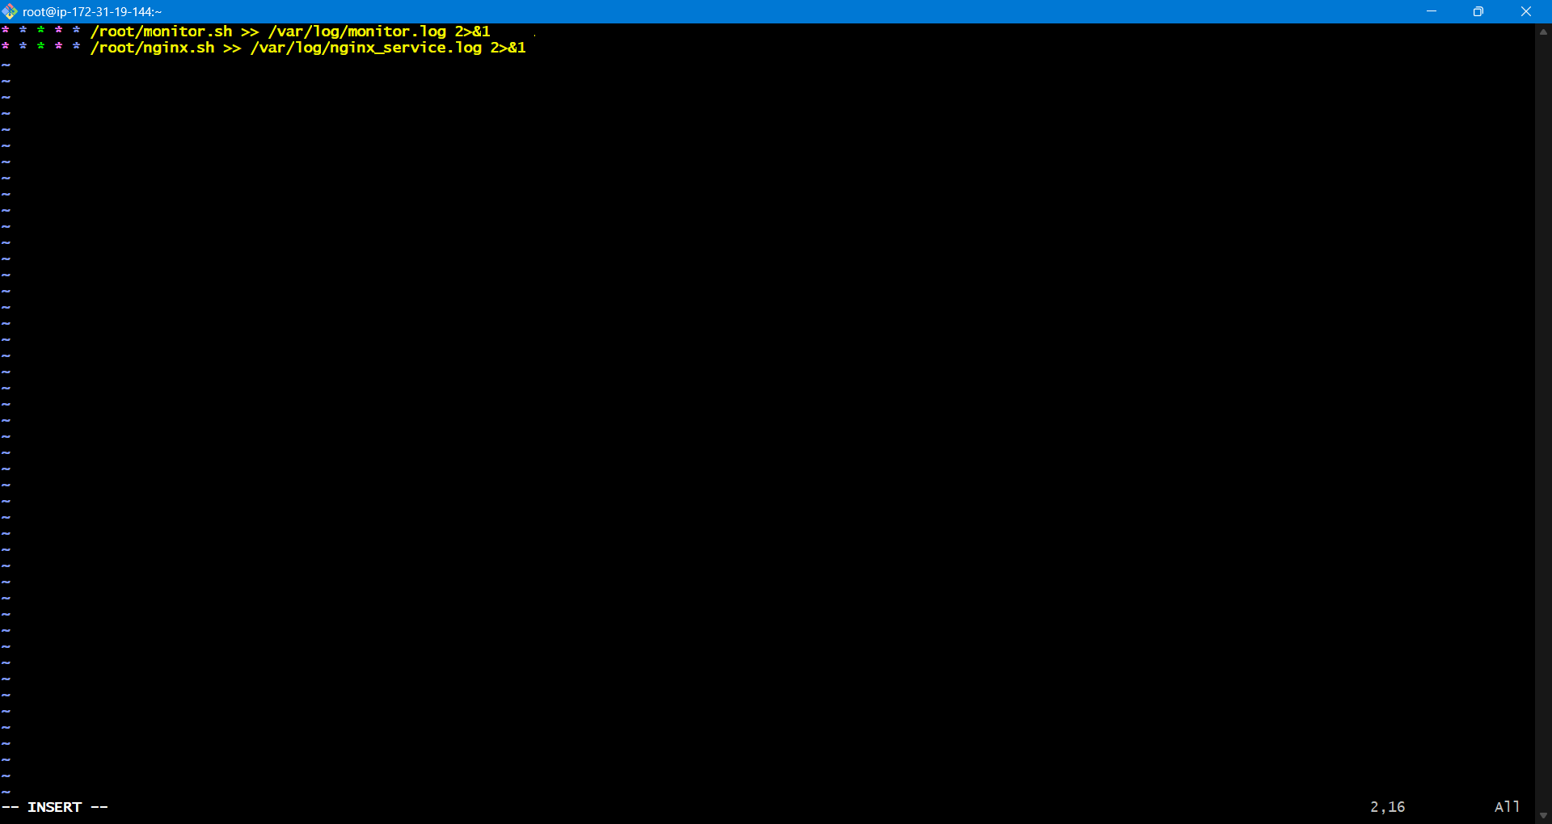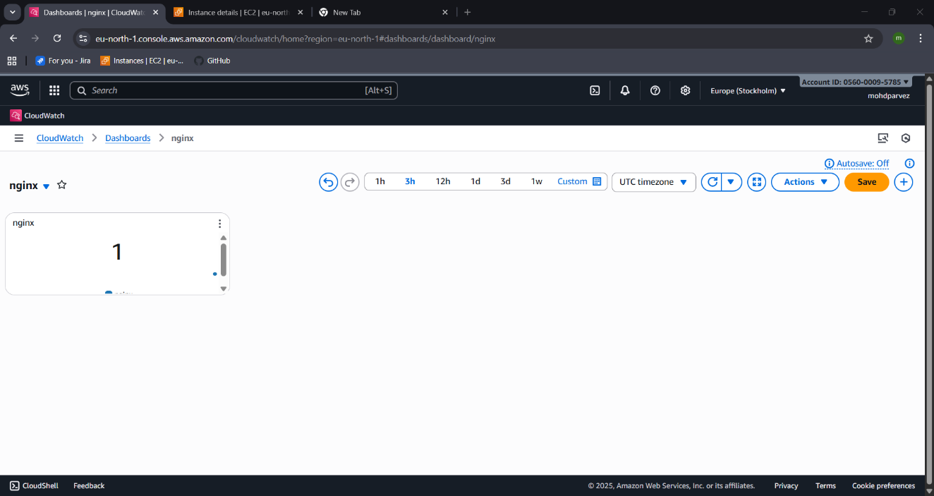
- go to the alarm in the cloud watch create alarm select the metricsselect the value create alarm
- then it will send the alert that in alarm if its zero
